NAME: SHOLOTAN ABDULAFEEZ AYOMIDE

MATRIC NO: HCSF/23/0089

LESSON 1

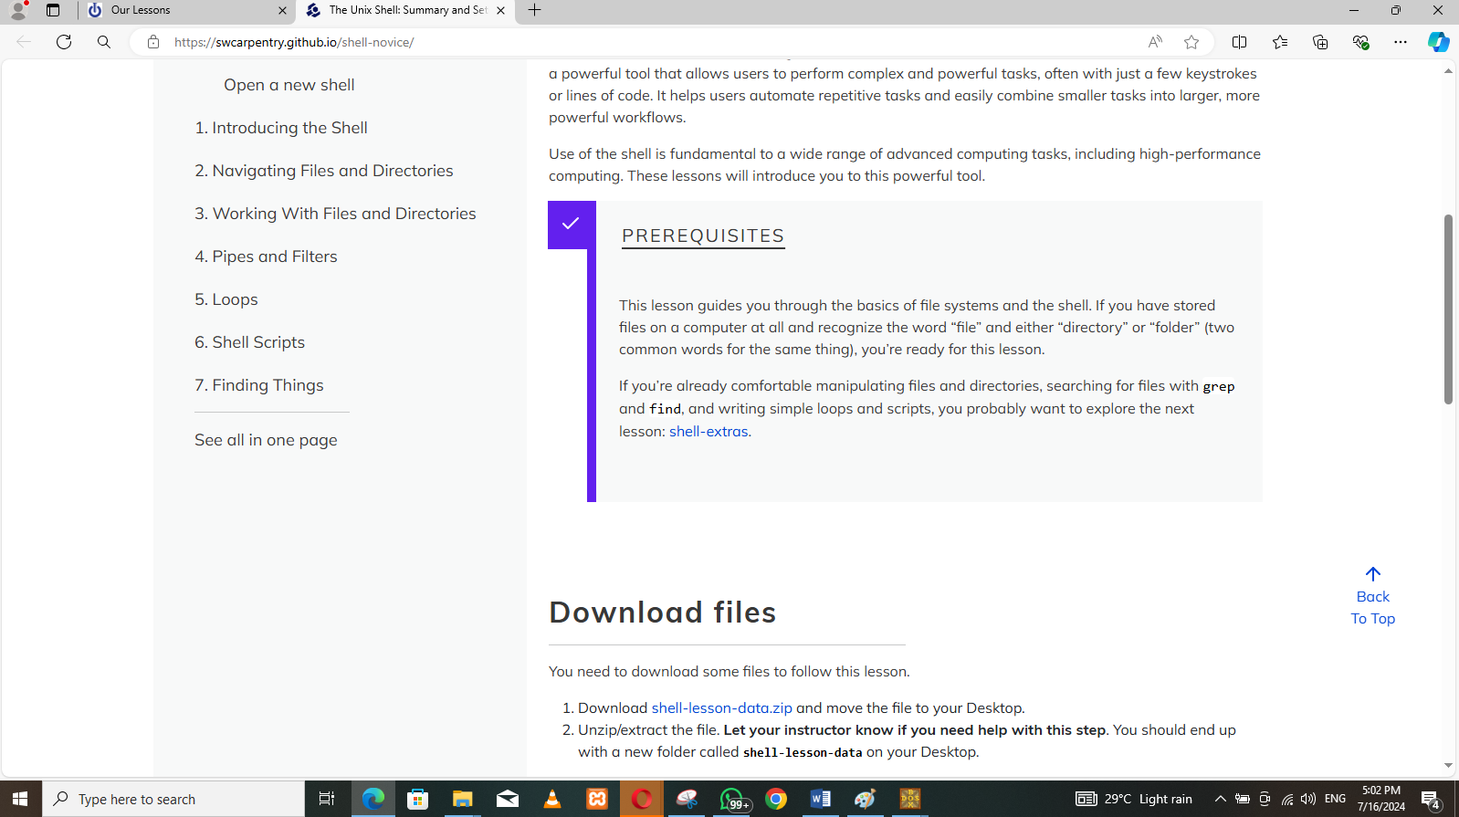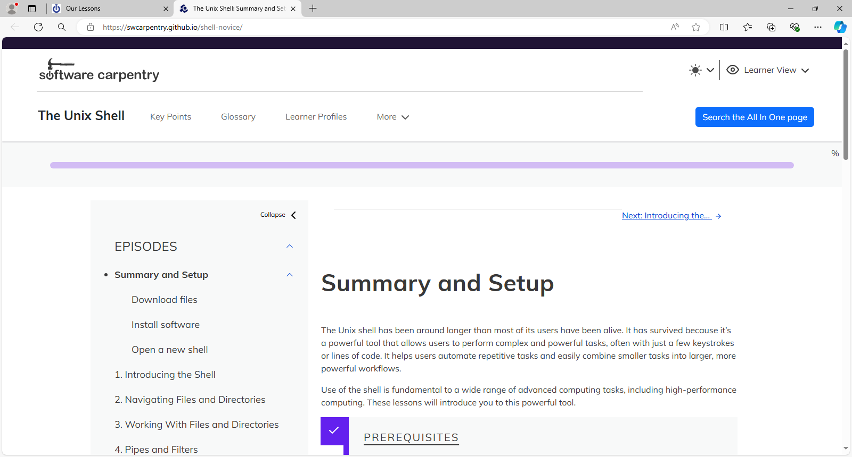

LESSON.2

